**List of Assignments**

This is the initial list of assignments. Any subsequent changes should be saved by contributors as a different version (i.e. List of assignments 1.1/1.2/1.3....) in order to keep track of the development of the project in time and for presentation purposes.

Suggestions for **name** of the website: SoftUNIfier, PloBoCop, …

**Tasks:**

|  |  |
| --- | --- |
| **“Must-Have“ List** | **“Nice-to-Have” List** |
| * Pages | * Functionalities |
| * Number of pages (4?/ to be determined) | * Search field/Results page |
| 1. Welcome/Home page | * Video clip as a background of the home page |
| 1. Gallery page(SoftUni pics with funny captions) | * Game in HTML/CSS on a separate page (i.e. FPS/duck hunter/…) |
| 1. Services (presentations/lectures/homework jokes?) | * Sound * Background music?! * Button click sounds?! |
| 1. “Contact/About us” page |  |
| * Navigation menu for the pages |  |
| * Logo |  |
| * Map of the world (Home page) |  |
| * Floating window with jokes for programmers |  |
|  |  |
|  |  |

Last contributor: Kiril

# 2. Initial drawing of the front page design:

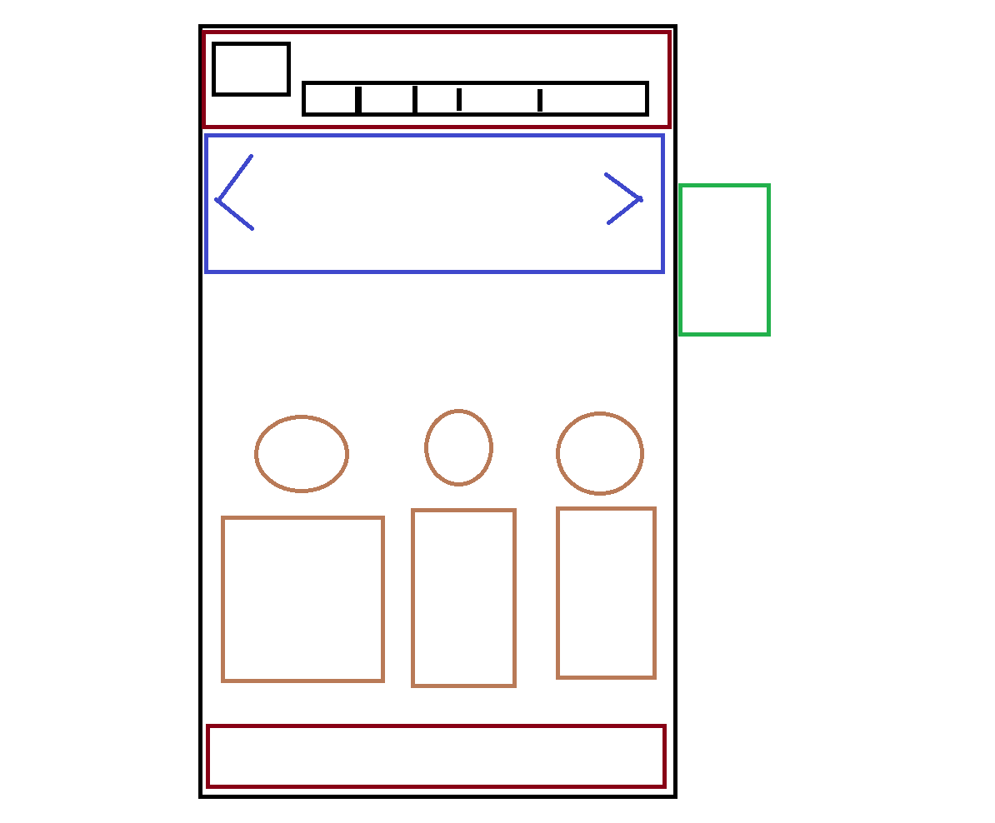

* The upper part is a list navigation
* Bellow the list is another navigation from a scrolling type
* The circles are icons on the top of a preview content from the side itself.
* The rectangular on the bottom is a footer
* The green rectangular on the right side is a dynamic (jokes) panel.